Урок № 63 Класс: 6-б Число: 16.03.16
Тема: Booking Theater Tickets
Заказ билетов в театр.
Цель:
- Изучение новых лексических единиц.
- Отработка навыков диалогической речи.
- Беседа о культуре заказа билетов по телефону.

- Организационный момент.
I’m waiting for the silence. Good morning children. Sit down, please. Prepare your books,
copy-books, dairies, vocabularies. We are starting our lesson.
- Формулировка новой темы и цели урока.
Have you ever been in the theatre? Have you ever booked the tickets? Please, look at the picture, page 82. What do you think, what will be our lesson about? What do you think what is the topic of our lesson? Yes, you are right – the topic of our lesson is “Booking Theater Tickets”.
Please, write down the date and the topic.
What will we do today, what do you think? Let’s say:
- We will learn new words;
- We will develop the skills of dialogue speech
- By the end of the lesson we will be able to make own dialogue
- Мотивация учебной деятельности учащихся
It will be very important to know, how we may book the theatre tickets. You see the dialogue in front of you. Please, read it.
- Усвоение нового материала.
R: Hello, Theatre Royal Haymarket. How can  help you?  C: Hello. I'd like to book some theatre tickets,  please.  R: Certainly. Which play would you like to see?  C: 'Hamlet', on Friday the 21st.  R: OK. How many seats would you like?  C: Two seats, please.  R: Fine ... There are available seats in the fourth  row, near the front, which cost £30 each, and  some nearer the centre ... £25 each. Which  would you like? | C: Mmmm ... The ones near the centre, I think.  R: So, two seats in row 11 ... Friday the 21st...  That comes to a total of £50. How would you  like to pay?  C: Can I pay by credit card?  R: Certainly. Just give me the number and the  expiry date.  C: 3959 3854 1104 9455. Expires this March.  R: And your name?  C: Mark Darcy.  R: Thank you, Mr Darcy. You can collect your  tickets at the theatre on Wednesday at 7pm.  The performance starts at 8 pm. Enjoy the  show.  C: Thank you very much.

- Закрепление нового материала.
Try to make your dialogue like in example. Use the phrases: How can I help you? I'd like to book some theatre tickets, please. Which play would you like to see? How many seats would you like? Can I pay by credit card?
How would you like to pay? The ones near the centre, I think.
- Саморефлексия: Tell your dialogue to your partner. Give your mark to each other.
- Итог: We have learnt new words/ We have developed skills of dialogue speech/ By the end of the lesson you are able to make your own dialogue.
Обучающиеся изучили новые лексические единицы. Обучающиеся отработали навыки диалогической речи. Обучающиеся были мотивированы придавать большое значение культуре разговора по телефону в момент заказа билетов в театр.

Открытый урок
на тему

Booking Theater Tickets.
Заказ билетов в театр

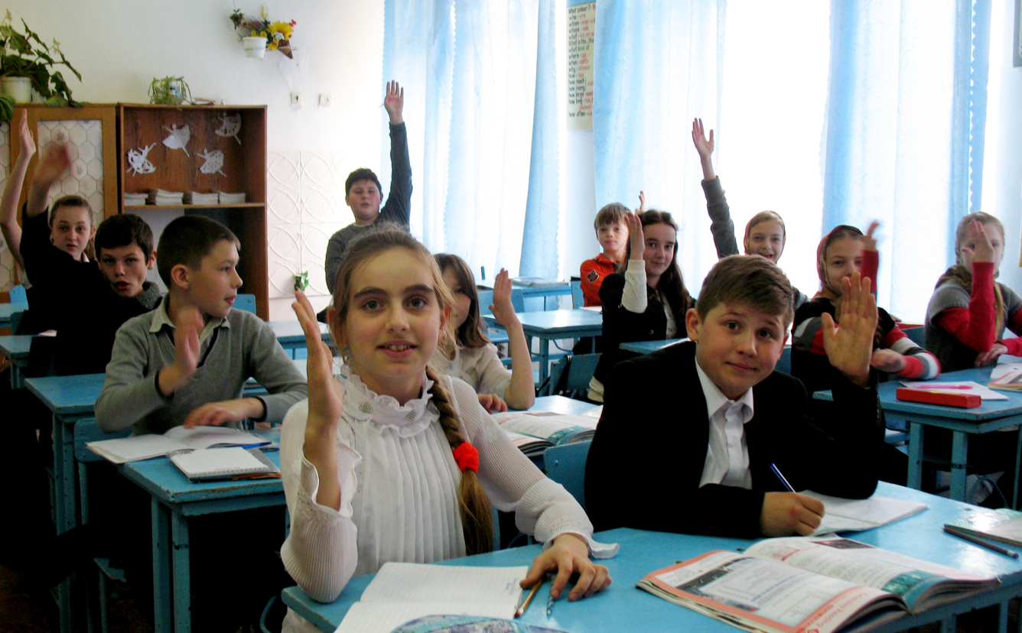
.
Учитель: Брижань Е.Ю.

