Урок № 82 Класс: 7-б Число: 29.04.16
Тема: Healthy body, healthy mind
В здоровом теле – здоровый дух
Цель:
- Введение новой лексики
- Формирование лексических навыков
- Беседа о здоровом образе жизни.

- Организационный момент.
I’m waiting for the silence. Good morning children. Sit down, please. Prepare your books,
copy-books, dairies, vocabularies. We are starting our lesson.
- Формулировка новой темы и цели урока.
Have you ever thought about healthy life? Have you ever done morning exercise? Today we are starting the new module. Please, look at the picture, page 95. What do you think, what will be our lesson about? What do you think what is the topic of our lesson? Yes, you are right – the topic of our lesson is “Healthy body, healthy mind”.
Please, write down the date and the topic.
What will we do today, what do you think? Let’s say:
- We will learn new words;
- We will form the lexical skills
- By the end of the lesson we will be able to talk about healthy life

- Мотивация учебной деятельности учащихся
It is very important to know, how we may do our life healthier. You see new words in front of you. Please, read it.
- Усвоение нового материала.
In new module we will read, listen and talk about the stress, accidents, health problems and advices. We will learn how to talk about health problems.
We will write a story about an accident

- Закрепление нового материала.
Many people nowadays suffer from cold and flu. What advice can you give to prevent it?
What should we do to be healthy?
We should wash our hands with soap.
We shouldn’t touch our eyes, nose and mouth.
We ought not to contact with sick people.
If we feel bad, we must stay at home and call the doctor.
We should wear flu masks in public places.
We ought to clean our rooms and wash the floors.
We should open the window regularly.
Your home task is to write recommendations to prevent cold and flu.
- Подведение итога урока. Оценки за урок.Today we have learnt to use modal verbs to give advice, learnt about healthy food and prevention from illnesses..
- Саморефлексия: Tell your words to your partner. Give your mark to each other.
- Итог: We have learnt new words/ We have formed lexical skills/ By the end of the lesson you are able to talk about healthy life.
Обучающиеся изучили новые лексические единицы. Обучающиеся сформировали лексические навыки. Обучающиеся были мотивированы придавать большое значение здоровому образу жизни.

Открытый урок
на тему:

«Healthy body, healthy mind»
В здоровом теле – здоровый дух

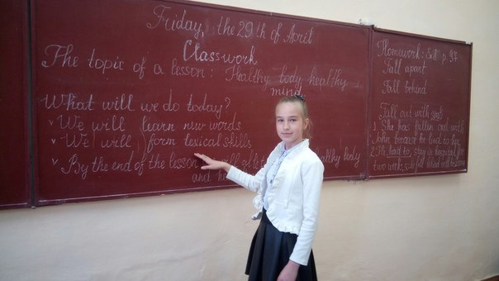
.
Учитель: Брижань Е.Ю.

